Project Design Phase-II
Technology Stack (Architecture & Stack)

Date | 31 January 3035
Team ID | SWTID-2026-7361
Project Name | AI Blog Nest API
Maximum Marks | 4 Marks

Technical Architecture:
The Deliverable shall include the architectural diagram as below and the information as per the table1 & table 2
Example: Order processing during pandemics for offline mode
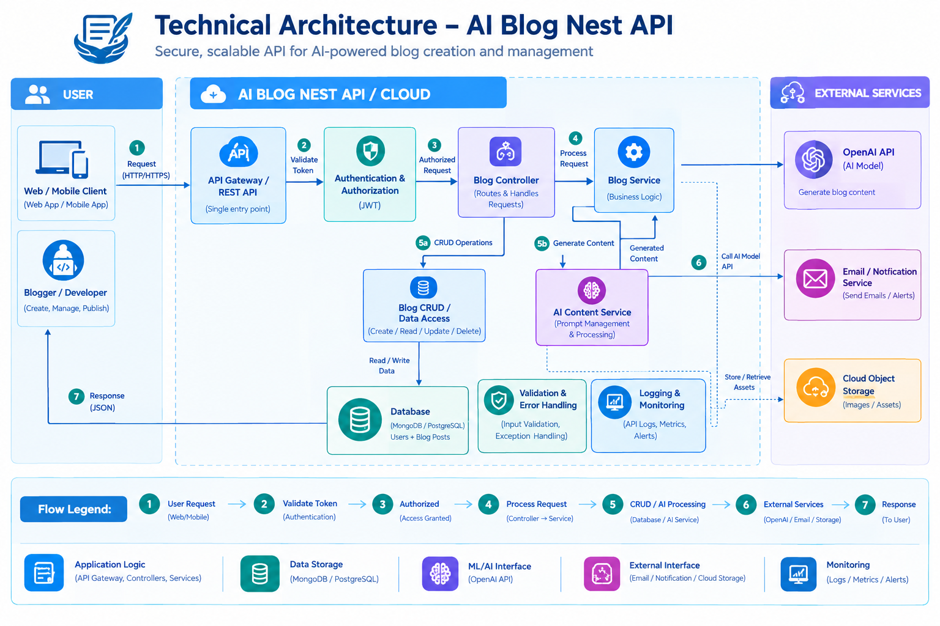
Table-1 : Components & Technologies:
S.No | Component | Description | Technology
 | User Interface | Interface through which users create, manage, edit, and publish blogs. | HTML, CSS, JavaScript, React.js
 | Application Logic-API |  | Node.js, Express.js
  Handles API requests, routing, validation, and responses.
 | Application Logic-AI Content | Processes user prompts and generates AI-powered blog content. | Python / Node.js, OpenAI API
 | Application Logic-Authentication | Handles user registration, login, authorization, and secure API access. | JWT, bcrypt
 | Database | Stores users, blog posts, prompts, generated content, and blog status. | MongoDB / Mongoose
 | Cloud Database | Provides scalable and reliable database storage when deployed on cloud. | MongoDB Atlas
 | File Storage
  Stores images, media, or other assets associated with blog posts.
  Cloudinary / AWS S3
 | External API-AI | Generates blog content based on the user's topic or prompt. | OpenAI API
 | External API-Authentication/Email | Used for email verification, password reset, or user notifications. | Email API / Nodemailer
 | Machine Learning / AI Model | AI model used to generate and assist with blog content creation. | OpenAI GPT Model
 | Infrastructure (Server / Cloud) | Hosts and deploys the API, database, and supporting services. | Node.js, Docker, AWS / Render / Vercel

Table-2: Application Characteristics:
S.No | Characteristics | Description | Technology
 | Open-Source Frameworks | Open-source frameworks are used to develop the frontend and backend API. | Node.js, Express.js, React.js, Mongoose
 | Security Implementations | Authentication, authorization, password protection, input validation, and secure API access are implemented. | JWT, bcrypt, HTTPS, Helmet, CORS, OWASP practices
 | Scalable Architecture |  | Node.js, Express.js, Docker, MongoDB Atlas, Cloud deployment
  The API uses a modular architecture where authentication, blog management, AI processing, and database operations can be scaled independently.
 | Availability | Cloud hosting and database services can provide reliable access to the API. Health checks and error handling help maintain service availability. | AWS / Render / Vercel, MongoDB Atlas, Docker
 | Performance | API performance is improved through efficient database queries, asynchronous processing, validation, caching where required, and optimized AI requests. | Node.js Async/Await, MongoDB Indexing, Redis Cache, API optimization

